date-26/1/23

Topic- java array

Declaration(3 way)

dataType[] arr;

dataType arr[];

dataType []arr;

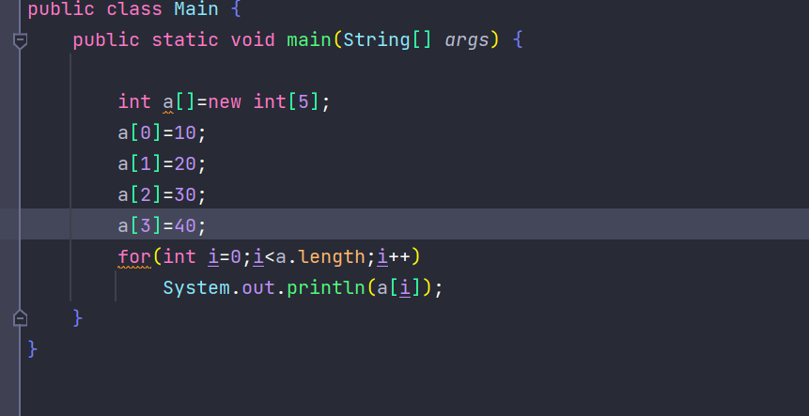

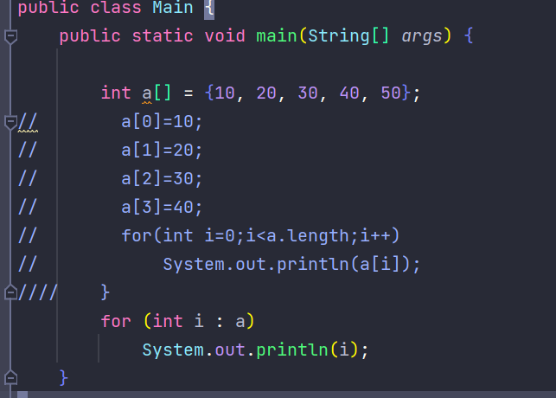

Using for-each loop for the array elements,